**✅ Day 5 Tasks**

**🐍 Python Tasks (Loops + Strings + Functions)**

1. Write a program to reverse a string without using built-in functions.

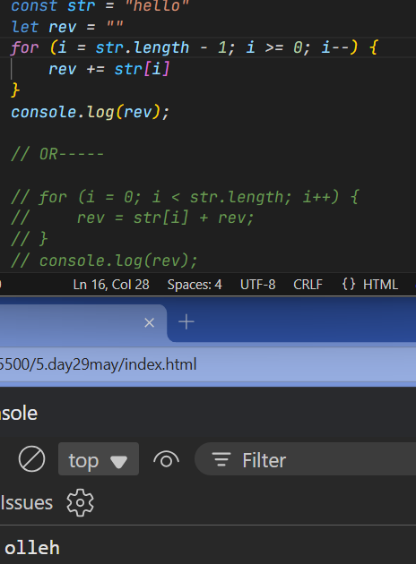

1. Write a function that takes a list of strings and returns a new list with strings that start with a vowel.

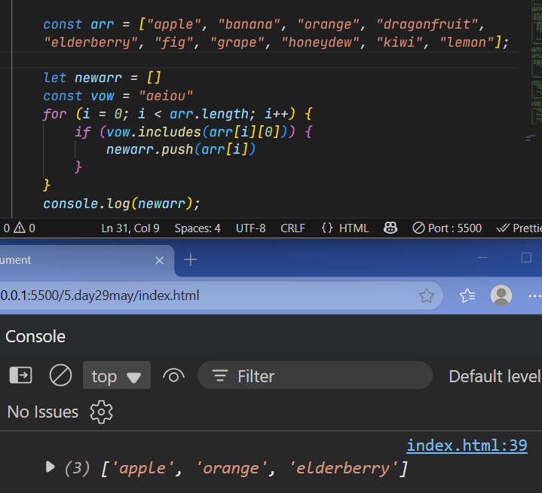

1. Write a program to print the Fibonacci series up to n terms using a loop.

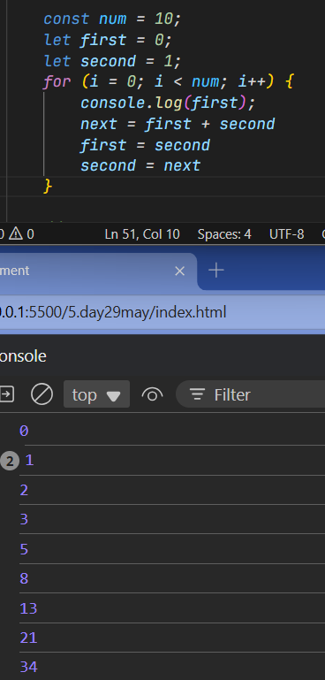

1. Create a function to check if a string is a palindrome

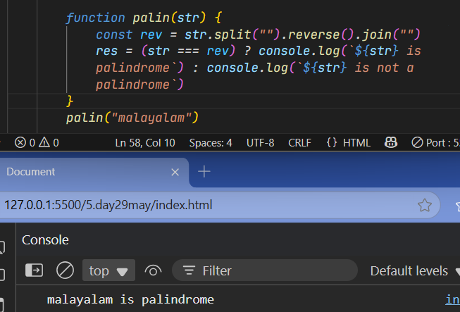

1. Write a program to count the number of words in a sentence entered by the user.

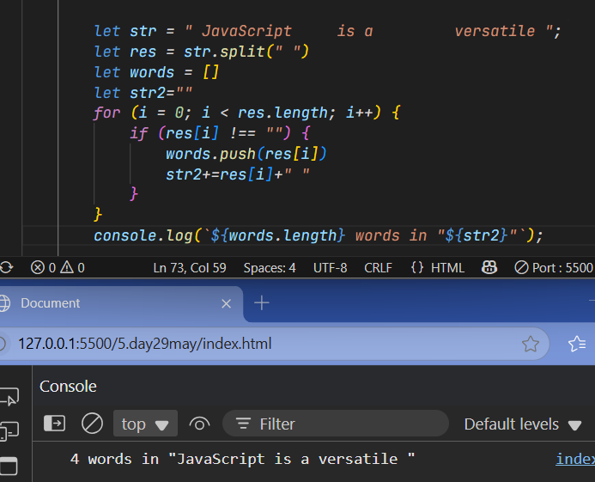

**🌐 JavaScript Tasks (Loops + Strings + DOM)**

1. Write a function to reverse a string and display the result using alert().

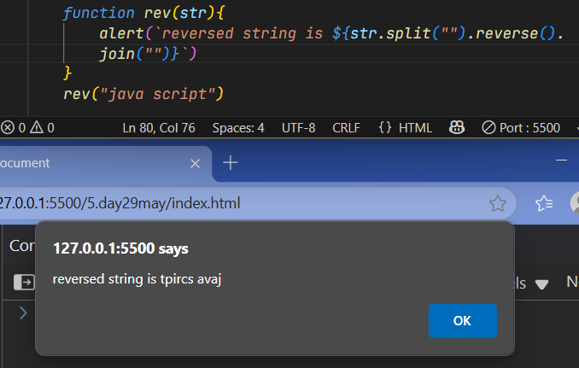

1. Create a form where the user enters a sentence. On clicking a button, display how many words are in that sentence in a <p> tag.

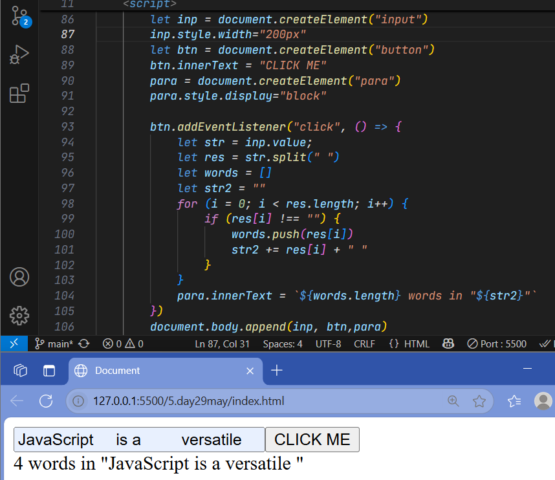

1. Create an array of names. When a button is clicked, display only the names that have more than 5 characters inside a <ul>.

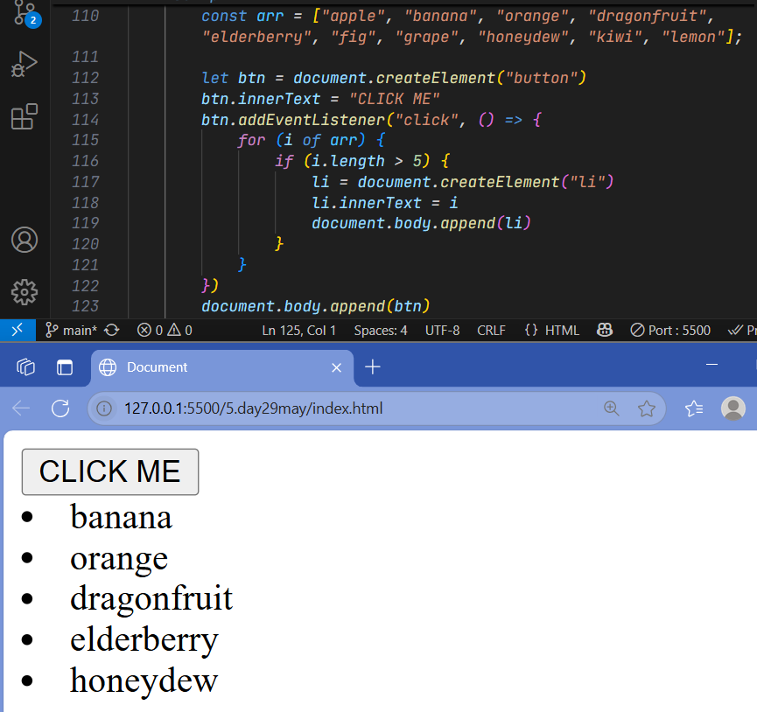

1. Write a function that takes a string and returns true if it's a palindrome.

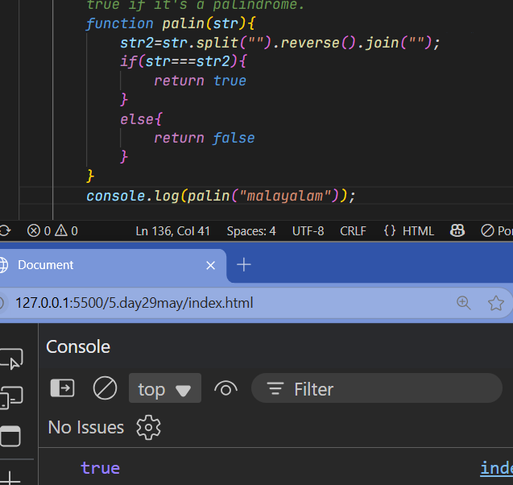

1. Create a loop that prints numbers from 1 to 50 in the console, but prints "Fizz" for multiples of 3, "Buzz" for multiples of 5, and "FizzBuzz" for multiples of both.
2. for(i=1;i<=50;i++){
3. if(i%3==0 && i%5==0){
4. console.log(i,"FizzBuzz");
5. }
6. else if(i%5==0){
7. console.log(i,"Buzz");
8. }
9. else if(i%3==0){
10. console.log(i,"Fizz");
11. }
12. }

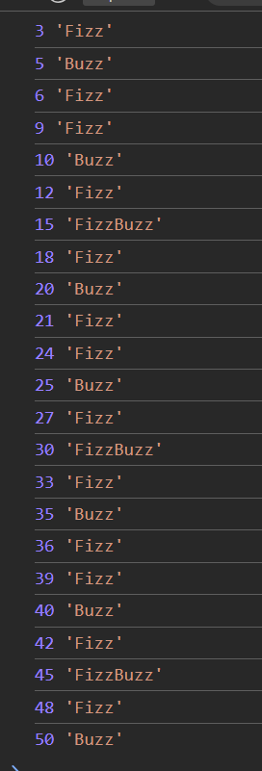

**🛢️ SQL Tasks (Functions + Aggregates + Filtering)**

1. Create a table named employees with columns: id, name, department, salary.
2. Insert 5 records into the employees table.
3. Write a query to find the average salary of employees.
4. Write a query to select employees who work in the "HR" department.
5. Write a query to increase the salary of employees in the "IT" department by 10%.

